Do Ontario Hospital Strategic Plans Translate Into Financial Performance?
HospitalIntelligenceR — HIT Analytics | Analysis HIT-03 | May 2026

Ontario public hospitals invest significant effort in strategic planning. Plans are developed by boards executives and staff teams over months, ratified at the board level, and used to organize internal effort and accountability for years. The working assumption is that this effort drives change.
There are 2 questions here.
1) do hospitals with strategic plans grow their revenues and manage their expenses differently than hospitals without them? And more directly,
2)do hospitals with explicit financial directions, perform better on financial measures than those that do not?
The short answer to both questions is no — at least not in any way that the data can reliably detect.

What We Measured
The first step was to identify and digitize hospital strategies. This was done by downloading strategic plans or strategy statements from 129 hospitals. Using an AI the strategic direction, description of that direction and any actions steps were extracted from the plans where possible. There is variation between the thoroughness of plans and in some cases no actions were captured and in a few only direction statements were captured. The AI was given explicit instructions to only report on actual text from the plans. This lowers the risk of hallucinations. The AI was also used to classify the Directions, into categories, which included Finance, and other directions. The results were audited, to ensure accuracy. This gives a relatively large data set on Ontario Hospital strategic plans
Ontario's Ministry of Health publishes annual financial and operational data for all public hospitals through its Hospital Information Tool. We used this data to construct year-over-year revenue and expense growth rates for 130 Ontario hospitals across six fiscal years from 2019/2020 through 2024/2025.
Because the sector as a whole moved through two major financial shocks during this period — the COVID-19 emergency funding surge in 2020/2021 and the post-COVID provincial reconciliation period in 2023/2024 — a raw revenue or expense growth figure for any individual hospital is difficult to interpret in isolation. A hospital that grew revenue by 12% in 2020/2021 was not performing unusually well; every hospital in the province received emergency MOH transfers that year. We therefore adjusted each hospital's annual growth rate by subtracting the field median for that year. All results below are expressed as percentage points above or below the sector median — For revenue,a positive number means the hospital outperformed the sector in that year; a negative number means it underperformed. The reverse is true for Expenses, a negative number means the hospitals growth in expenses was less than the sector, while a positive number means its expenses grew faster than the sector.
We matched these financial trajectories to strategic plan data from HospitalIntelligenceR's strategy workstream. To ensure that a plan had enough time in place to plausibly influence financial outcomes, we applied a minimum two-year tenure filter: a hospital had to have had its current strategic plan in place for at least two fiscal years to be included in the primary comparison. This produced a primary group of 55 hospitals, with plan adoption years ranging from 2015 to 2023. A further 65 hospitals had plans adopted in 2024 or 2025 and did not yet meet the tenure threshold. Ten hospitals had no recoverable plan.
Four hospitals were excluded from all financial calculations as structural outliers — two with anomalous COVID-era provincial funding for transitional care and hospital-at-home programs that inflated their revenue and expense figures beyond any reasonable comparability, and two with capital construction or amalgamation events that similarly distorted the series.

Strategic Plans and Financial Trajectories
Among the 55 hospitals with plans in place long enough to analyze, the median cumulative field-adjusted revenue growth across the full post-plan window was +1.9 percentage points. Cumulative expense growth was +0.4 percentage points. Both figures are slightly above zero, meaning the typical hospital in this group tracked modestly ahead of the sector median on both dimensions over the life of its plan.
Among the 10 hospitals with no recoverable plan, the comparable figures were −1.9 percentage points for revenue and −2.1 percentage points for expense.
However, the no-plan group is small — ten hospitals with a revenue standard deviation of 15.8 percentage points, which means a 95% confidence interval that runs from roughly −12 to +8 points. A gap of this size could easily reflect the particular composition of hospitals in this group rather than the presence or absence of strategic planning. The no-plan hospitals are also disproportionately Large Community hospitals, a type that showed stronger financial trajectories than Small Community hospitals across the full dataset. If anything, that composition bias works against the observed gap, meaning the true plan-versus-no-plan difference is likely smaller than the raw numbers suggest.
We are also not able to rule out selection effects. Hospitals that are financially healthier may be more able to invest in strategic planning; the causation may run in the opposite direction from what the comparison implies. With ten hospitals in one group, this analysis is best treated as a descriptive baseline rather than a finding about the causal effect of planning.

Does an identified Financial strategy actually help?
Within the 55 with-plan hospitals, 24 — just under half — had at least one strategic direction with a primary theme of financial sustainability. We call this the FIN group. The remaining 31 hospitals addressed financial themes incidentally or not at all at the primary direction level.
The 43% FIN prevalence in this group is consistent with the sector-wide rate from our broader strategy analysis, which found 44% of Ontario hospitals with classifiable plans naming financial sustainability as a primary strategic direction. The 55-hospital planning group is not unusually finance-focused relative to the sector.
On revenue, FIN hospitals averaged +0.5 percentage points of field-adjusted cumulative growth; non-FIN hospitals averaged +1.3 percentage points. The medians are nearly identical: +1.8 and +1.9 points respectively. With standard deviations of 6.5 and 6.9 points, these groups are statistically indistinguishable. Thus it appears that having a strategic direction related to financial sustainability does not appear to improve revenue performance relative to peers.
The expense results are more suggestive of a positive effect. FIN hospitals averaged −0.2 percentage points of field-adjusted expense growth — fractionally below the field median. Non-FIN hospitals averaged +0.7 points. The medians reverse the pattern: FIN hospitals +0.5, non-FIN hospitals −0.7 but in neither is statistically significant.
The means show a small directional advantage for FIN hospitals on expense control — growing expenses fractionally slower than the field compared to non-FIN hospitals — but the medians reverse this pattern. Neither difference approaches statistical significance given standard deviations of approximately 6.6 percentage points in both groups

The Trajectory Picture
Aggregated summary statistics — means and medians — compress a great deal of hospital-level variation. We therefore plotted the year-by-year field-adjusted trajectories for all 55 with-plan hospitals, aligned to years since plan initiation rather than calendar year. This alignment is intentional: a hospital that adopted its plan in 2016 and one that adopted in 2022 both start at position zero on the x-axis, making their post-plan trajectories directly comparable regardless of what was happening in the broader sector at the time.
What the resulting graph shows is a wide fan of individual hospital experiences. Most hospitals in most years are within roughly five percentage points of the field median on both revenue and expense. The group median line — the orange trace running through the centre of the bundle — sits close to zero across the first two post-plan years, when all 55 hospitals are represented. After year two, the number of hospitals in the comparison declines as shorter-tenured plans drop out of the window, and the median line becomes less representative of the group as a whole.
Hospitals that outperform in year one do not systematically outperform in year two, and hospitals that underperform early do not systematically recover. The individual lines cross freely throughout the window. This is the visual signature of noise, not of a systematic plan effect.
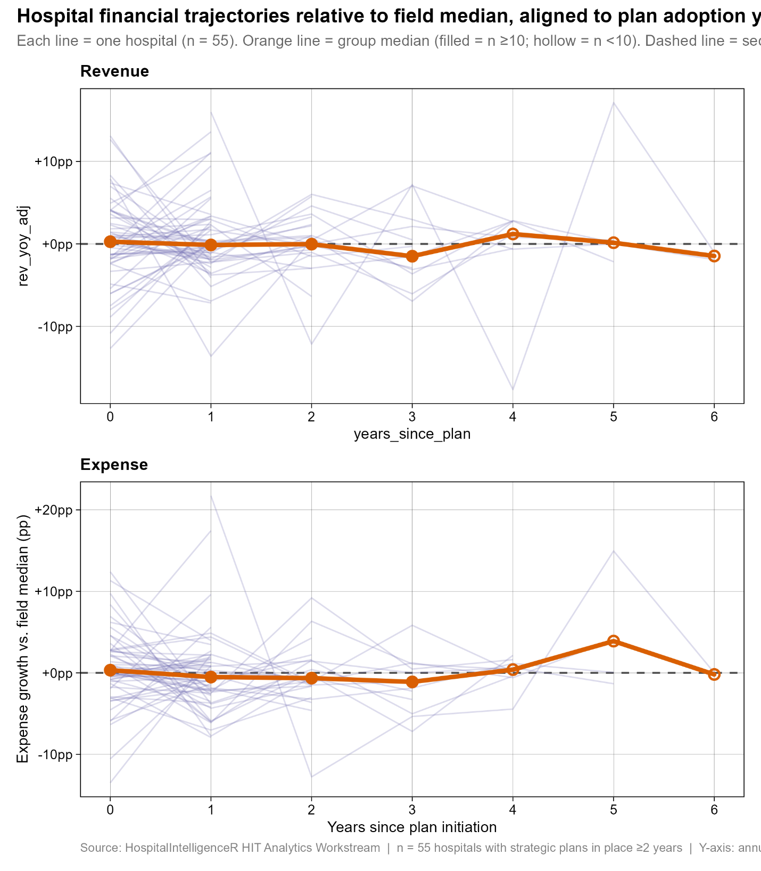

What This Means
The absence of a detectable plan effect is itself a meaningful finding, and it is consistent with what we found in an earlier analysis of Ontario hospital financial trajectories more broadly. Hospitals in this province operate under shared regulatory constraints, common funding mechanisms, and substantially similar operational pressures. The sector median is not a passive reference line — it is an active gravitational force that pulls hospital finances toward common ground year after year. Individual hospital choices, including the strategic choices formalized in plans, operate within that constraint rather than above it.
This does not mean strategic planning is without value. Plans may drive accountability, align boards and management, and structure organizational decision-making in ways that are not visible in annual revenue and expense trajectories. A hospital that enters a period of capital investment or organizational restructuring may absorb short-term financial pressure deliberately — outcomes that would appear as underperformance in this framework are in fact planned strategic moves. The data does not distinguish between these scenarios.
What the data does say is that hospitals should not expect their strategic plan's financial emphasis to show up reliably in MOH-reported revenue and expense figures. If a board is using financial trajectory relative to peers as the primary signal of whether its strategic plan is working, it is likely reading from the wrong instrument.

Implications for Boards and CEOs
Boards, executive teams and staff invest significant resources in strategic planning cycles. That investment may be well spent — but the return on it is not likely to be visible in year-over-year financial performance relative to the sector. If the goal of naming Financial Sustainability as a strategic priority is to produce measurably better financial outcomes than peer hospitals, the evidence does not support that expectation.
CEOs and Board Chairs whose organizations are below the field median on revenue or expense should be cautious about attributing that position to an inadequate strategic plan, or expecting that a stronger, more detailed emphasis on financial sustainability will close the gap. The field median is a powerful anchor, and most hospitals track close to it regardless of what their strategic plans say.
The more useful question for boards may not be whether their hospital's financial trajectory differs from peers, but why. That question requires a different kind of analysis — one that looks at case-specific context, capital cycles, and service mix changes rather than at aggregate trajectory comparisons. The strategic plan may be the right starting point for that conversation, but the MOH financial series is the wrong ending point.

Data and Methods Note
Financial data: Ontario Ministry of Health Hospital Information Tool, fiscal years 2019/2020 through 2024/2025. Indicators used: total MOH revenue (ind01 + ind02), total patient services expenses (ind05 + ind06). Year-over-year changes computed from the annual series; field-adjusted by subtracting the annual sector median across all 130 in-scope hospitals before plan-group or FIN-group splits are applied. Structural outliers excluded before field median calculation.
Strategic plan data: HospitalIntelligenceR strategy extraction workstream, 576 directions across 129 hospitals. FIN classification uses primary theme assignment only; a hospital with FIN as a secondary theme only is counted in the non-FIN group. Plan tenure filter: ≥2 fiscal years of HIT data available from the first post-plan year. Hospitals with plan adoption years of 2024 or later do not meet this threshold and are excluded from Tables HIT-03a through HIT-03d. One merged entity (FAC 983 Huron Perth Healthcare Alliance) is absent from HIT data under its consolidated FAC code and is excluded from all financial trajectory analysis.
HospitalIntelligenceR HIT Analytics Workstream | May 2026

Individual strategic directions sometimes cover more than one topic, and it those cases the direction was assigned a primary and secondary topic. The primary topic, was identified by the AI and audited to ensure accuracy. However, and as noted, this does introduce some subjectivity.

